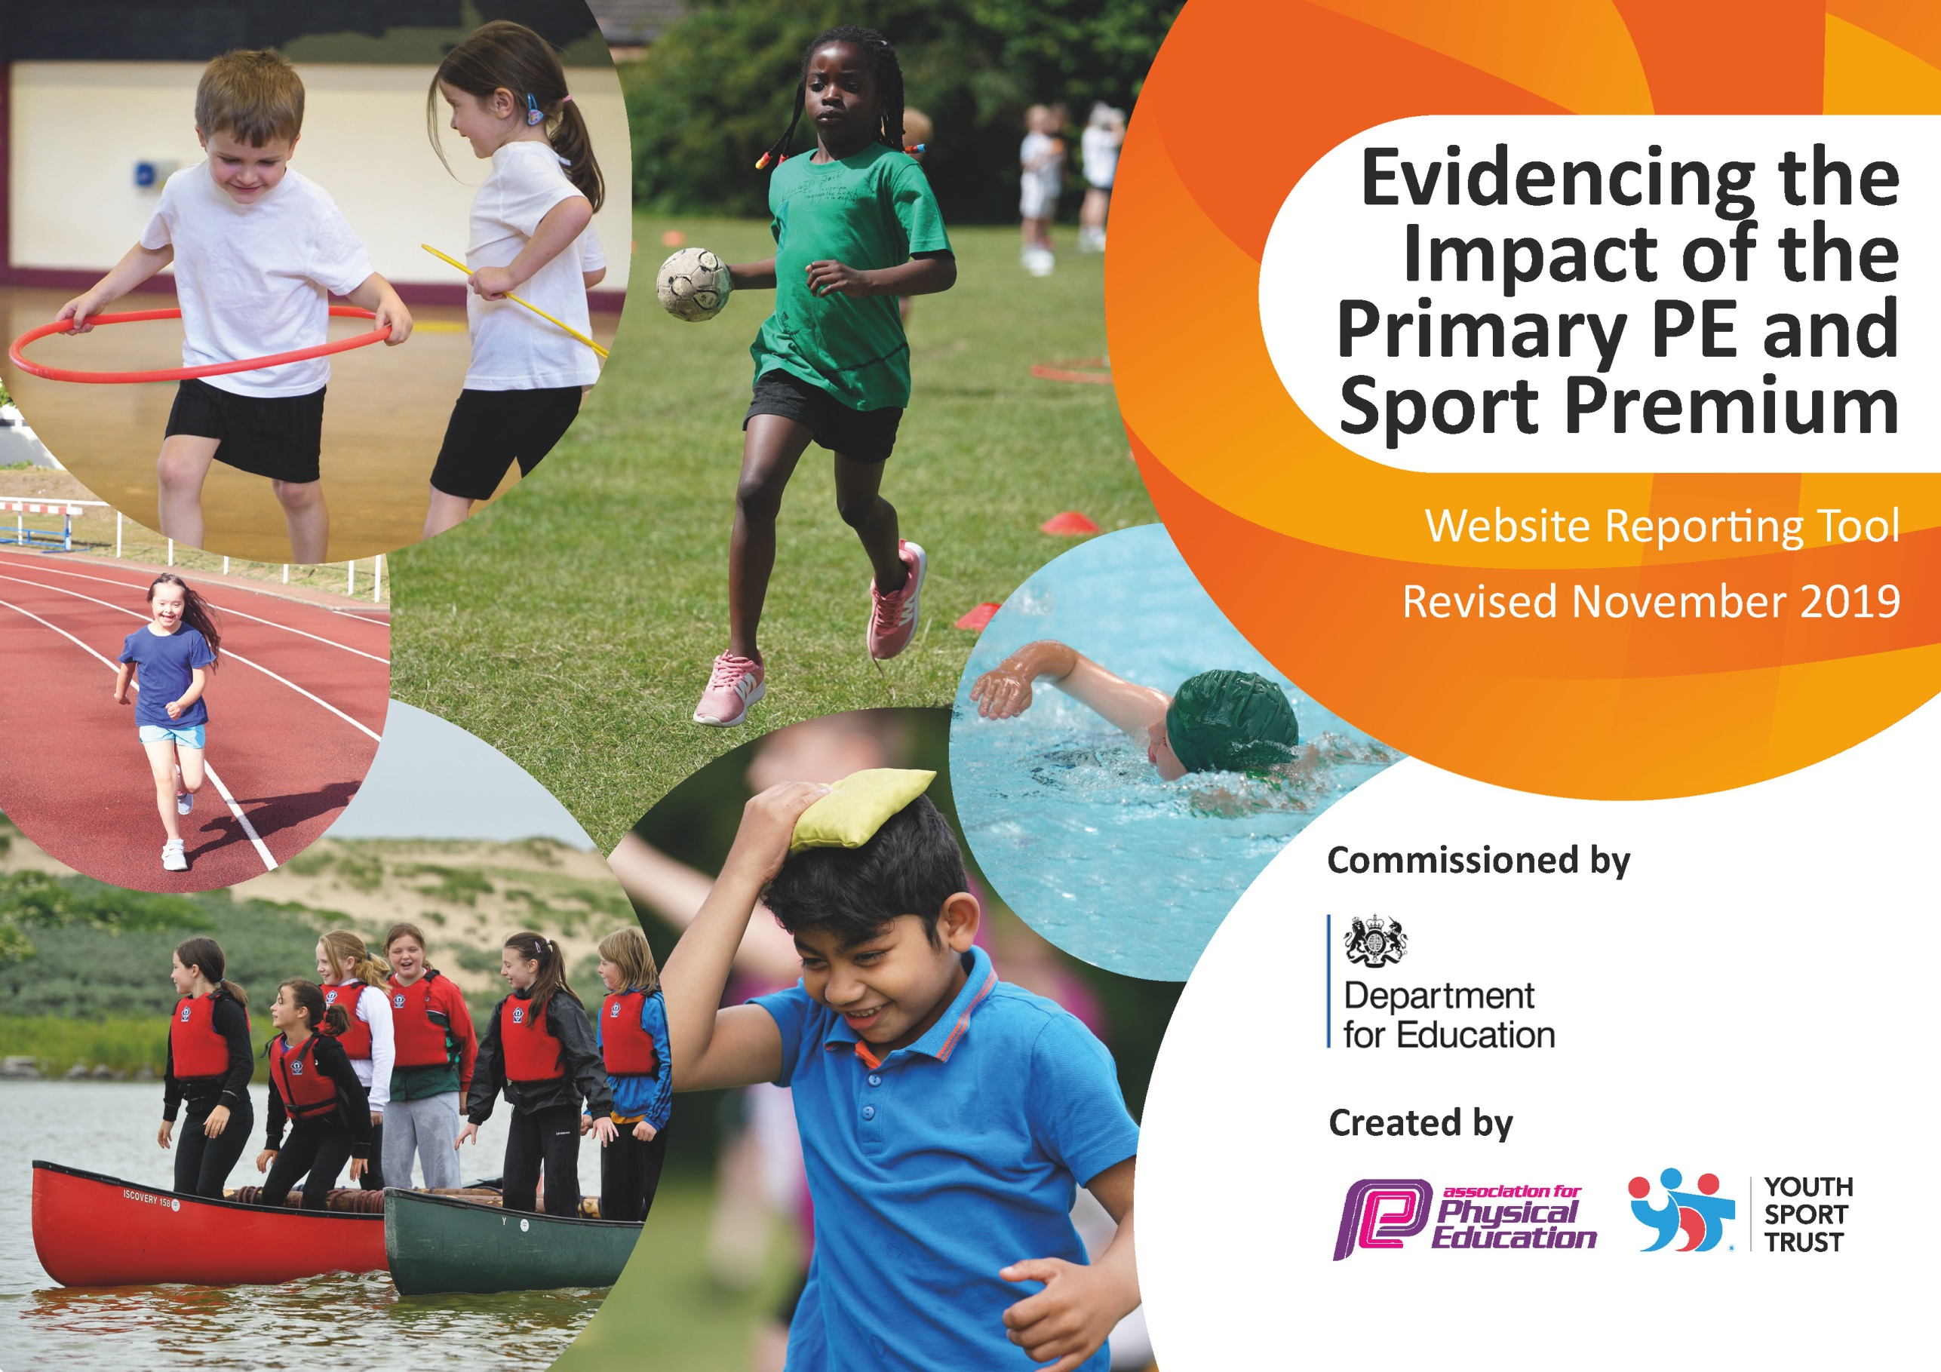
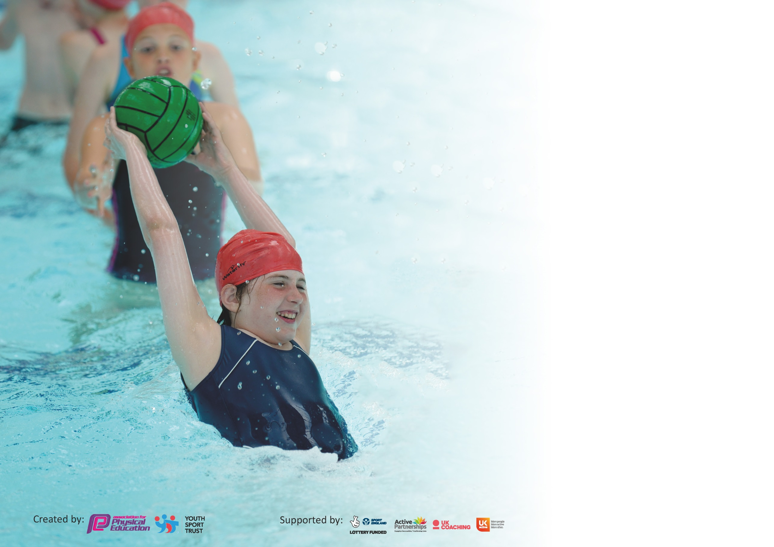

It is important that your grant is used effectively and based on school need. The Education Inspection Framework (Ofsted 2019 p64) makes clear there will be a focus on ‘whether leaders and those responsible for governors all understand their respective roles and perform these in a way that enhances the effectiveness of the school’.

Under the Quality of Education criteria (p41) inspectors consider the extent to which schools can articulate their curriculum (INTENT), construct their curriculum (IMPLEMENTATION) and demonstrate the outcomes which result (IMPACT).

To assist schools with common transferable language this template has been developed to utilise the same three headings which should make your plans easily transferable between working documents.

Schools must use the funding to make additional and sustainable improvements to the quality of Physical Education, School Sport and Physical Activity (PESSPA) they offer. This means that you should
use the Primary PE and Sport Premium to:

- Develop or add to the PESSPA activities that your school already offer
- Build capacity and capability within the school to ensure that improvements made now will benefit pupils joining the school in future years

Please visit gov.uk for the revised DfE guidance including the 5 key indicators across which schools should demonstrate an improvement. This document will help you to review your provision and to report your spend. DfE encourages schools to use this template as an effective way of meeting the reporting requirements of the Primary PE and Sport Premium.

We recommend you start by reflecting on the impact of current provision and reviewing the previous spend.

Schools are required to publish details of how they spend this funding as well as on the impact it has on pupils’ PE and sport participation and attainment by the end of the summer term or by 31st July 2020 at the latest.

We recommend regularly updating the table and publishing it on your website throughout the year. This evidences your ongoing self-evaluation of how you are using the funding to secure maximum, sustainable impact. Final copy must be posted on your website by the end of the academic year and no later than the 31st July 2020. To see an example of how to complete the table please click HERE.

Support for review and reflection - considering the 5 key indicators from DfE, what development needs are a priority for your setting and your pupils now and why? Use the space below to reflect on previous spend and key achievements and areas for development.

Key achievements to date until July 2019: | Areas for further improvement and baseline evidence of need:
CPD through specialist coaches for staff in different areas of PE – Games and Gymnastics.  - Play leader employed for active lunchtimes.  - High quality resources for children to use.  - Children more active during lunchtimes and playtimes – play leader and mini leaders supporting.  - Children more active during lessons  - All children taking part in intra school competitions throughout the school year.  -children given opportunities to try different sports in school-orienteering, archery etc.  - Increase in number of children taking part in inter school competitions and festivals (football, fundamentals)  -Children have had opportunities to experience different sports and create local club links-tennis, rugby.  -Forest level 3 TA trained and qualified | -Continue to develop the KS1 and Reception outdoor areas to create opportunities for more active play with permanent and non-permanent resources  - Encourage more children to attend afterschool clubs.  -Offer more lunchtime clubs  - Train staff to implement the new PE scheme of work and assessment tool.  - CPD for staff on delivering sessions on dance and movement.  – Mini leaders to work with and support younger members of the school.  - Embed physical activities into the daily timetable by looking for more active ways to teach lessons.  -Explore ways of encouraging and embedding healthy eating/living  -Extend Forest School provision in school

Action Plan and Budget Tracking
Capture your intended annual spend against the 5 key indicators. Clarify the success criteria and evidence of impact that you intend to measure to evaluate for pupils today and for the future.

Academic Year: 2019/20 | Total fund allocated: £17 116
Key indicator 1: The engagement of all pupils in regular physical activity – Chief Medical Officer guidelines recommend that primary school pupils undertake at least 30 minutes of physical activity a day in school
Intent | Implementation |  | Impact
All pupils to make progress in each lesson/unit/year.  Development of their fundamental skills and movement to help develop fine and gross motor skills.  Children to have the opportunity to try a range of different sports and become more active.  Children will be able to develop new skills and continue these at after school clubs.  Children to be more active throughout the school day during curriculum time  Children to be more active during lunchtimes and playtimes.  All children are more active during the school week | PE resource audit and new PE equipment bought providing a good range of quality PE equipment.  All children to access one hour a week extra sport-engage in new activities.  Book a range of different sporting taster sessions.  Promote and encourage children to take part in after school clubs and local sport clubs – leaflets and assemblies. Advertise the clubs on the school website and newsletters.  Audit and buy new playground equipment for lunchtimes.  School council come up with ideas to enhance the playground.  Mini leaders to lead sporting activities for the children to take part in.  Healthy schools lunchtime audit to improve engagement at lunchtimes.  Develop the playground to create more opportunities for physical activities.  Book sporting coach to work with children in Change for life sessions – targeting less active/confident and PP children | PE equipment - £800  Play time equipment - £00 Play leader – As below  Coaches for Change for life, Mini leaders, dance sessions, additional experiences and taster sessions-£9000 | PE equipment audit Evidence shown during PE sessions and in children’s writing, teacher feedback and learning walks.  School websites and newsletters Staff feedback, pupil feedback, lesson observations.  Teacher feedback Observations, Class timetables  Children/staff feedback, MDS feedback, play leader feedback Children/teacher feedback  Healthy School audit | All children will access 2 hours of high quality PE using high quality equipment.  Fine motor activities will be embedded into the school timetable in Year 1  Increase number of pupils attending after school clubs Increase number of pupils physically active at playtimes.  Next steps Continue to build links with the Junior school and their mini leaders to help develop an active lunch-time.  Continue to target less active pupils in school to become more active and healthy.  To develop more active lessons/activities within the school timetable
Key indicator 2: The profile of PESSPA being raised across the school as a tool for whole school improvement
Intent | Implementation |  | Impact
Celebration assembly every week to ensure the whole school is aware of the importance of PE and Sport and to encourage all pupils to aspire to being involved in the assembles.  Engage children in a range of physical activities at lunchtime.  Children’s behaviour will improve during lunchtimes and lesson times.  Engage children in a range of physical activities at lunchtime and afterschool.  Children will development their fundamental skills and movement  Children will develop leadership skills.  Children to be more active throughout the school day. | Achievements celebrated in assembly.  Display children’s achievements on a display board.  Different activities to be available at lunchtimes for the children to participate in.  Buy new resources for lunch times.  activities with the children at lunchtime. Lunchtime playtime leader – plan and run daily sessions  Train year 2 children to become mini leaders for Foundation stage children during lunch times  To use dance sessions to promote citizenship and work within the community-performances and links with the old peoples home. | N/A  Equipment – as above  Play leader wage –£4689  Coaches-mini leaders and dance as above | Festivals and competition video’s available in classrooms for parents to watch, assemblies.  pupil feedback, photographs.  Play leader planning, teacher and MDS feedback.  Healthy school audit feedback.  Staff feedback, pupil feedback, lesson observations. | Raise the profile of PE and sport in the school with children and staff.  Children share their sporting achievements increasing positivity towards sport  Parents aware of sporting achievements.  Increase number of pupils taking part in daily exercise  Increase number of pupils being active at lunch time.  Targeting less active children  Next steps  Develop lunchtime activities – introducing new areas  Develop more active lessons and activities throughout the day  Different classes to do dance/gymnastics displays which they have learnt for cluster festivals.

Key indicator 3: Increased confidence, knowledge and skills of all staff in teaching PE and sport
Intent |  | Implementation |  | Impact
Higher standards in PE lessons throughout school and ensuring progression throughout the whole school.  Develop skills and knowledge of all staff when assessing and planning lessons.  Opportunities to improve and develop team building skills, listening and communication skills.  Increase engagement and enjoyment of children in lessons.  Enhance and develop teacher’s skills in teaching different sports – creating boarder and high quality PE lessons for the children.  Engagement in competitions and inter school events. |  | Analysis data so that impact can be measured over time.  Staff training CPD – REAL PE  Staff training CPD courses – Dance artist, Qualitas, Real PE.  Book specialist sports teacher to come and work alongside and train up staff in different areas of PE  PE learning walks throughout the school year - Monitor assessment & lesson planning.  All staff to be confident and competent to teach a range of activities in PE.  Staff to feedback to all staff when they attend a PE course. | CPD – included in coaching fees  Events and festival package-£3410 | Learning walk, data analysis, work scrutiny, termly assessment  Teacher feedback  lesson observations, pupil feedback, photographs  Staff feedback from learning work  Pupil feedback, teacher feedback | All staff will be supported to feel confident to deliver PE and Sport both within and outside the curriculum.  Staff will work together and share good practice which will lead to better confidence all round.  Children will have chance to experience and develop a range of new skills.  Next steps  Plan further CPD PE  Introduce new PE scheme.  Invest in training for new PE leads.
Key indicator 4: Broader experience of a range of sports and activities offered to all pupils
Intent | Implementation |  |  | Impact
Pupils will have experiences and opportunities to take part in a range of PE activities.  Children will have opportunities to try new sports in school in addition to regular PE sessions  Children will take part in a range of different sporting festivals and competitions. | Staff training CPD – courses & working alongside coaches  All staff to work alongside coaches to develop their skills in teaching different sports  All children take part in extra sessions throughout the year-new sports, forest school, dance, festivals.  Book free taster sessions from local sports clubs  Assembly and newsletters to promote afterschool clubs and sporting events.  Promote and encourage children to attend afterschool clubs through assemblies, newsletters and the school website.  Affiliate to the Qualitas to access a broad range of festivals.  Take children to a range of PE festivals and competitions with other schools from the cluster. |  | CPD/coaching - As above  Events as above | planning, teacher feedback, pupil feedback  play leader feedback, photographs, pupil feedback.  play leader/teacher/pupil feedback.  festival/competition registers | Staff will work together and share good practice which will lead to better confidence all round.  The school is no longer dependent on 'experts' coming in to teach PE and Sport as staffs are more confident and keen.  Increase of pupils attending inter competitions and festivals  Next steps  Introduce school sports week promoting different activities.
Due to the Covid-19 pandemic and school closing in March and only reopening to 30% of children in June the programme that was planned for this year has been temporarily halted. Once risk assessments are in place for whole school reopening we will continue with these plan and will publish an action plan on how to spend next year’s budget along with the money saved in 2019-2020.

Key indicator 5: Increased participation in competitive sport
Intent | Implementation |  | Impact
Children have opportunities to compete within school and with other children and schools.  Children will feel part of a team.  Children will have the opportunity to try a range of different sporting activities.  Children are engaged and motivated to be physically active during lunch time.  Gives children opportunity to create their own games, work together and improve their PE skills.  Children feel a sense of achievement when taking part in lunchtime activities.  Children will develop skills in competitive sports.  Children will participate in inter cluster events, competitions and festivals. | PE coordinator attend Qualitas meetings to engage in events with local schools.  Plan and organise sports day  Continue to employ a lunchtime playtime leader – daily  Work with playtime leader to organise and plan activities.  Mini leader training for year 2 children.  Book a range of taster sessions. | Events package and CPD as above | Photographs  festival/competition registers  Play leader planning, photographs  Observation, play leader feedback.  feedback, observations. | Increase of pupils attending inter competitions and festivals  Pupils develop team building and working together skills.  All children take part in inter competitive activities and events.  Increase number of pupils taking part in inter school competitions.  Next steps  Introduce personal challenges into weekly PE lessons and lunch time activities.  Plan competitive activities within the school calendar.

